 | KY DECA NEWSLETTER
 | | NOVEMBER 2022 |
 | 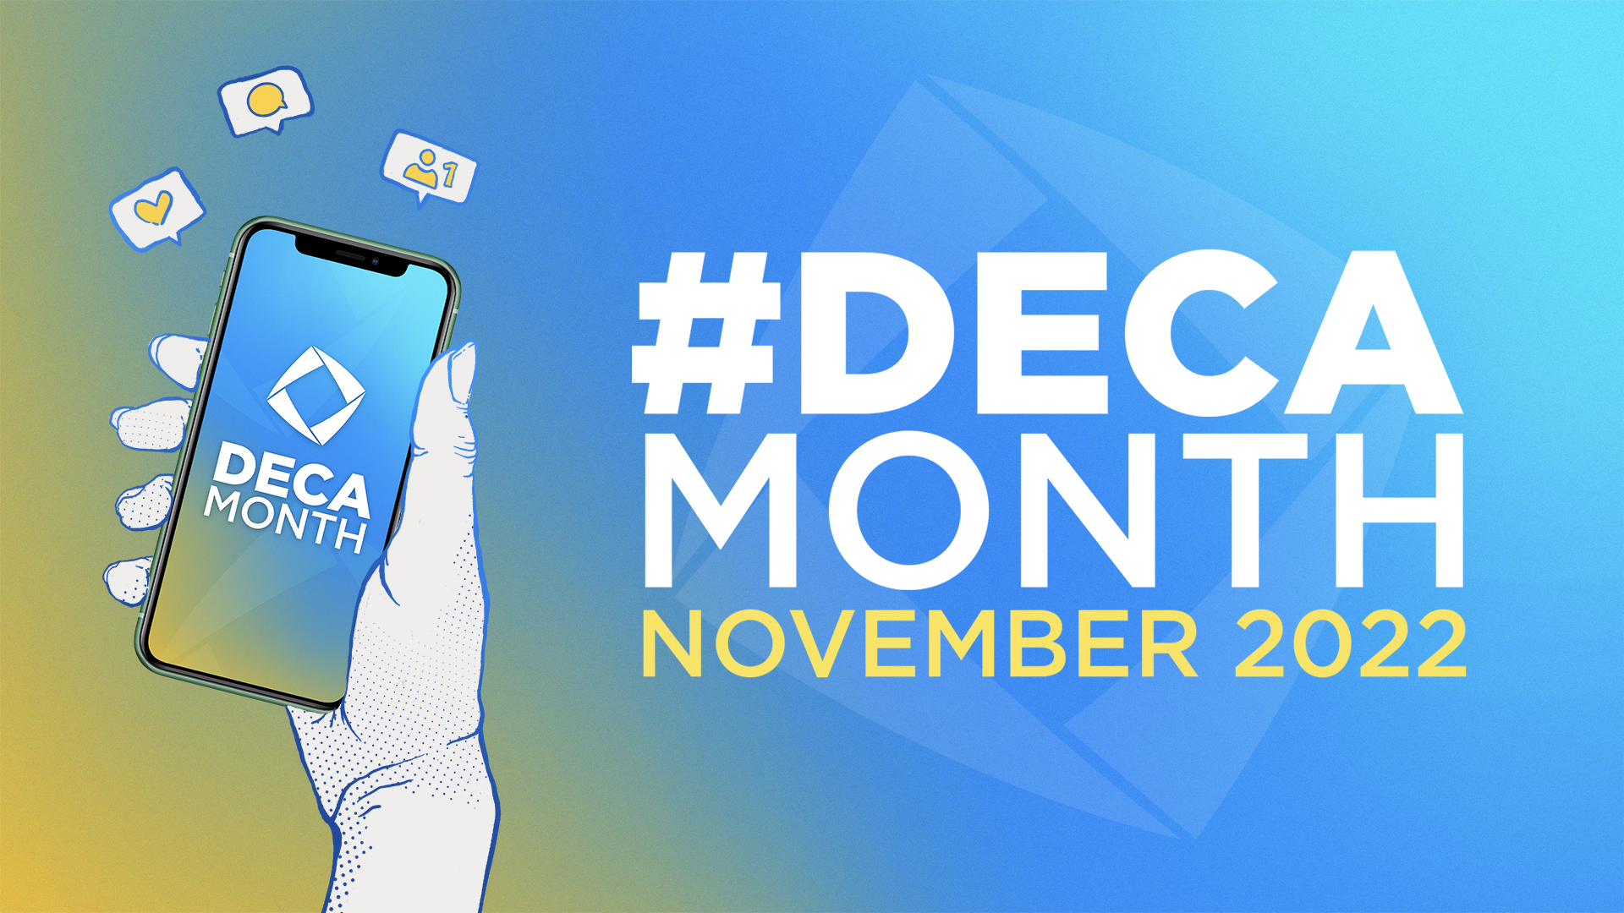  Though November is DECA Month, it is also packed full of holiday jitters and cheer. Here at KY DECA, we are excited to embrace the holiday season as we approach Region!  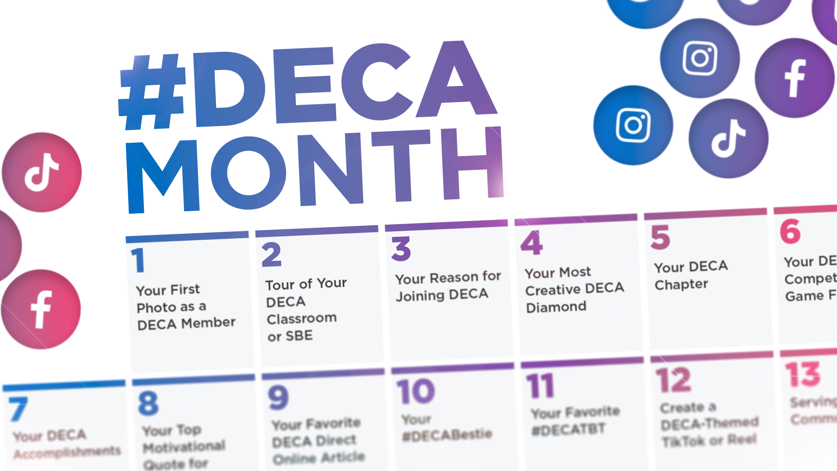 |  |  |  |  | November

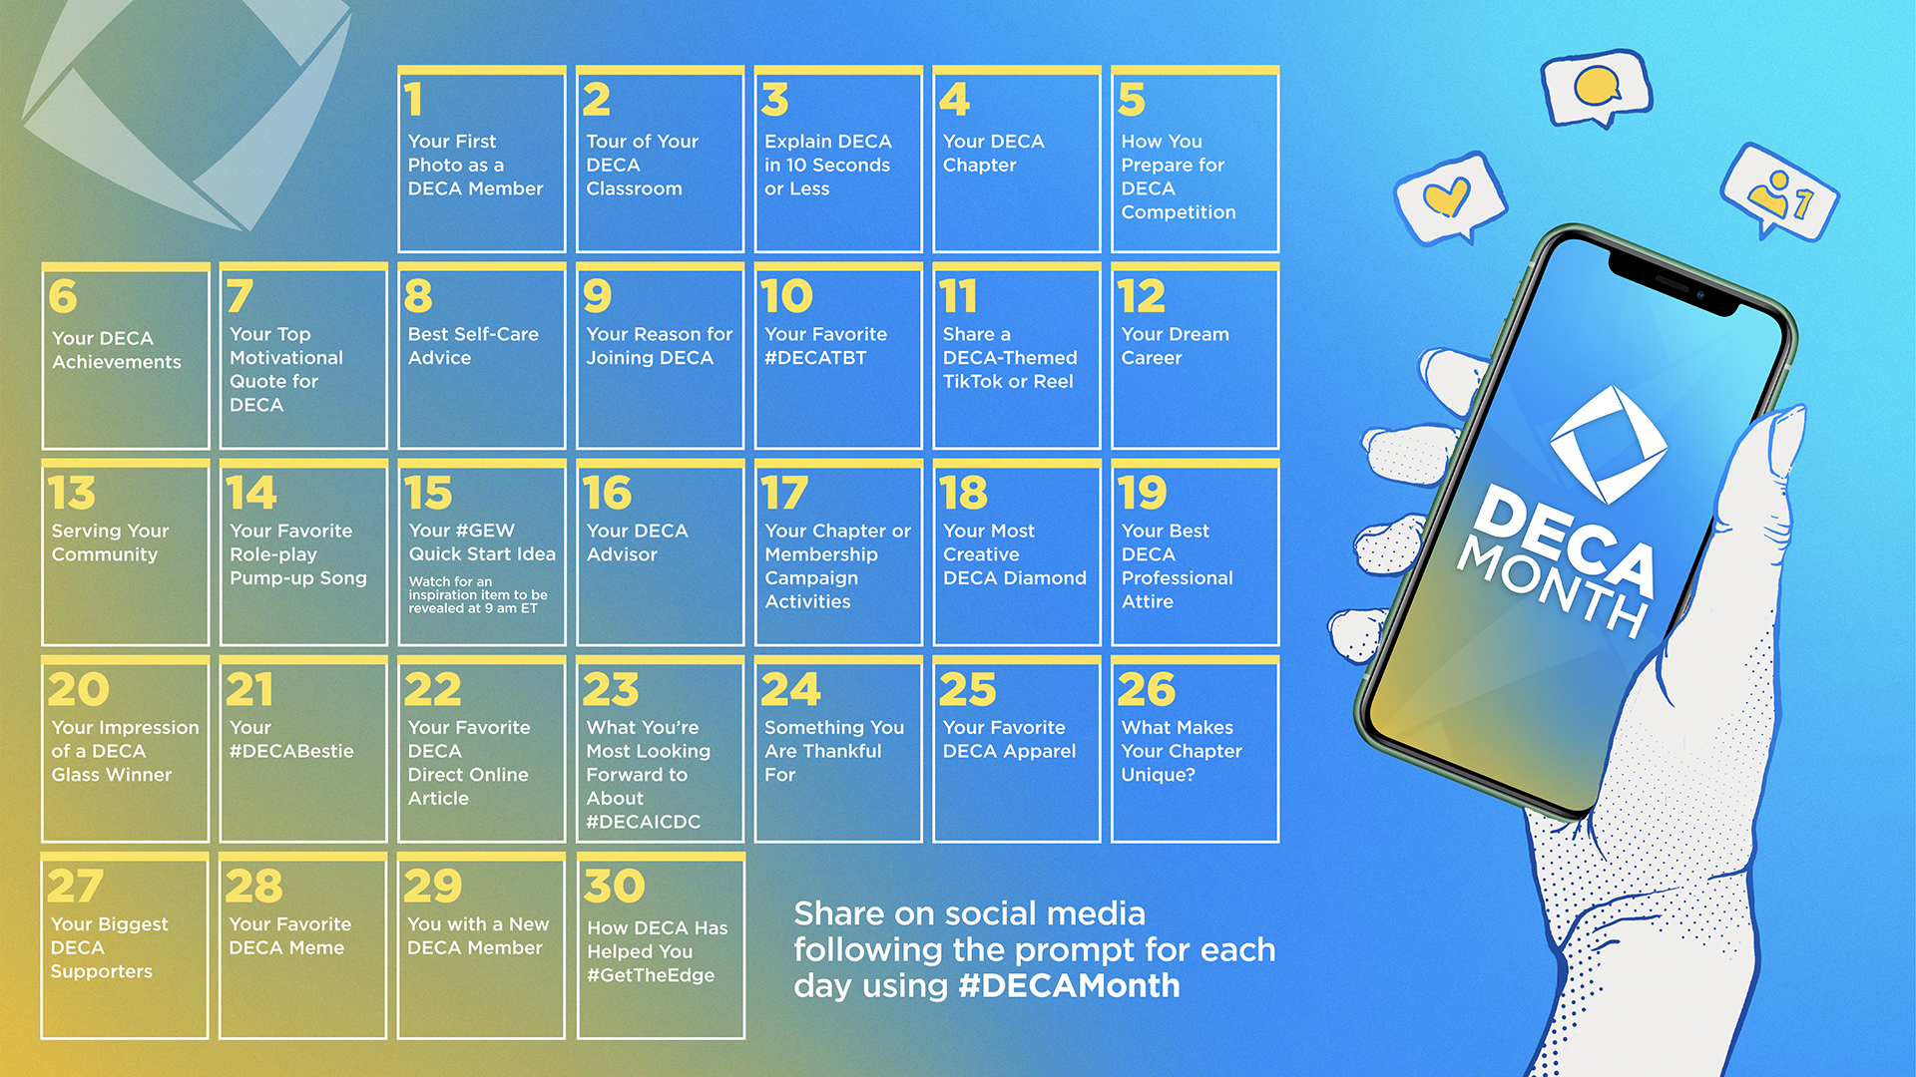
DECA MONTH
 | #DECAMonth is the ultimate celebration of all things DECA. From recalling your favorite DECA memories and completing chapter campaigns, to attending events and sharing your DECA story, November is all about the many reasons you love being a DECA member. |  |  |  | You can check out Kentucky DECA’s #DECAMonth posts on our Instagram page, @kentuckydeca where each member of our executive council has had the opportunity to share about their own experiences with DECA.
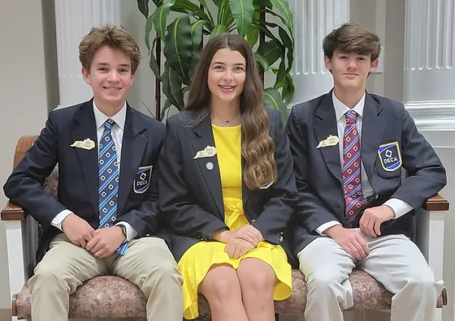
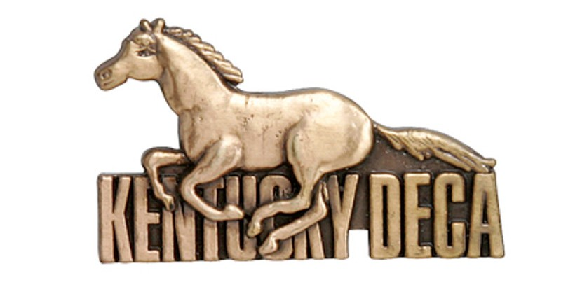
COMPETITION TIPS
Arrive at your event ON TIME. Try to be there at least 15 minutes early to your designated location.
Prepare for your event by reviewing materials found on the DECA Inc. website. You can find your scoring sheets and performance indicators on your event-specific page, which are extremely useful.
Dress to impress! Before we get to region, make sure that you have the proper attire as stated on the DECA guide, which can be found on DECA Inc.’s website, deca.org.
Most importantly, don’t stress! You’ll learn from experience and will have fun doing it!
With competition season approaching, we’ve included some tips for incoming members to succeed in their events! We wish you the best!
LOOKING FORWARD:
DECA REGION CONFERENCE DATES!
January 25, 2023 – Region 1 @ MSU, Murray
January 27, 2023 – Region 4/5 @ EKU, Richmond
February 1, 2023 – Region 2/3 @ WKU, Bowling Green

