Kentucky DECA 2023-2024

Student Forms

This packet contains forms that are required to be completed in order for students to attend and participate in Kentucky DECA activities and functions for 2023-2024. Please read and complete the following forms:

- Conference Delegate (Student & Adult) Conduct Practices and Procedures

- KY DECA Dress Code

- CTSO Medical Release and Covid 19 Waiver Form

- Photo/Video Release and Waiver

- Kentucky DECA Honor Code

CONFERENCE DELEGATE (STUDENT & ADULT) CONDUCT PRACTICES AND PROCEDURES

HIGH SCHOOL DIVISION

1. The term "delegate" shall mean any DECA Member, including Advisors and adult chaperones attending DECA-related conferences (High School, Collegiate, Alumni, Professional).

2. There shall be no defacing of public property. Chapters responsible for any damages to any property or furnishing in the hotel rooms or building will be held responsible.

3. Delegates shall keep their adult advisors informed of their activities and whereabouts at all times.

4. Delegates should be prompt and prepared for all activities.

5. Delegates should be financially prepared for all activities.

6. Delegates will spend the nights at the conference hotel in their assigned rooms.

7. Delegates will be in their assigned sleeping room throughout the conference curfew hours and will be quiet and respectful of other guests in the hotel.

8. Casual wear will only be accepted during specific social functions as designated during orientation sessions.

9. No alcoholic beverages or narcotics in any form shall be possessed by any delegates at any time, under any circumstances.

10. Cigarette smoking/vaping is not permitted by any student delegate.

11. No delegate shall leave the hotel (except under authorized events) unless permission has been received from Chapter Advisors.

12. Delegates are required to attend all general sessions and activities assigned, including workshops, competitive events, committee meetings, etc., for which they are registered.

13. Delegates must wear identification badges at all times while on the conference property and outside their sleeping room.

14. The Dress Code will be in effect at all times. (See KY DECA Dress Code page for details.)

15. Each Chapter/District is responsible for their delegates’ conduct.

- Delegates violating or ignoring any of the conduct rules will subject their entire delegation to being unseated and their candidates or competitive events participants being disqualified. Individual delegates may be sent home immediately at their own expense.

I have read and agree to conform to the policies established by DECA:

Parent/Guardian Signature |  | Chapter Advisor Signature
Student/Adult Delegate Signature |  | School Name

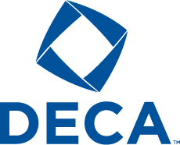
KY DECA Dress Code
(This form is required but retained by the chapter advisor)

These guidelines apply throughout the conference for any conference activity except for the game night where casual attire* is appropriate.

Female - Name badge required at all times.
The skirt/dress length must be at or below the knee.
Dress blouse or dress sweater with dress skirt or dress slacks (blazer optional) or business dress; dress shoes; for a more polished, professional appearance, it is recommended that attendees wear appropriate hosiery/trouser socks.
*ANY DRESS OR BLOUSE/SWEATER WITH A COLLAR REQUIRES A SCARF/ASCOT REQUIRED FOR TESTING, ALL COMPETITIONS AND WHILE ON THE CONFERENCE STAGE.
Unacceptable examples (not inclusive): sandals of any kind, shoes without backs, casual style shoes (canvas, etc), gaucho pants, skintight or revealing clothes, midriff-baring clothing, leggings, jeggings or graphic designed hosiery/tights, athletic clothing.
Male - Name badge required at all times.
Collared dress shirt and necktie with dress slacks (blazer/dress coat is optional); dress shoes and dress socks.
*NECKTIE REQUIRED FOR TESTING, ALL COMPETITIONS AND WHILE ON THE CONFERENCE STAGE.
Unacceptable examples (not inclusive): sandals of any kind, casual style shoes (hiking, canvas, sneakers), cargo style pants, jeans or other casual pants, T-shirts or shirts without collars, Sweaters of any kind unless worn with a collared dress shirt.

*Unacceptable examples (Not inclusive) for the Casual night: Skin-tight or revealing clothing, clothing with printing that is suggestive, obscene or promotes illegal substances, swim wear, night wear. Shoes required.

___________________________________________ | _________________________________________
Parent/Guardian Signature | Chapter Advisor Signature
___________________________________________ | _________________________________________
Student/Adult Delegate Signature | School Name

CAREER AND TECHNICAL STUDENT ORGANIZATION

ACTIVITY MEDICAL RELEASE/PARENT PERMISSION FORM

INSTRUCTIONS: Students, parents/guardians and chapter advisors must complete this form for each student participant as a prerequisite for the student to attend a career and technical student organization activity. Each chapter advisor must bring the completed forms to the student activity.

Student:________________________________________Parent/Guardian:___________________________________

Street Address:_________________________________City:______________________________Zip________________

Phone (Work):_________________________________(Home):_______________________________________________

Alternate Contact:__________________________________________Phone(Work):______________________________

Street Address:_________________________________City:______________________________Zip________________

Student’s Doctor:__________________________________________Phone:____________________________________

Street Address:_________________________________City:______________________________Zip________________

Advisor:_________________________________________________School:____________________________________

Administrator:___________________________________School Phone:_______________________Fax:_____________

Student covered by group or other medical insurance as follows: Provide name of:

Insured:________________________________________Insurance Company:_________________________________

Group #:_____________________________________________Policy #:_______________________________________
Please describe completely any medical condition (past or present) being treated, which may recur or be a factor in medical treatment (include allergies, medicine reactions, disease of any kind, physical handicap, heart or lung problems, seizures, convulsions, blackouts, etc.) If currently taking medication, state the medication and prescribing physician and phone number:

I give permission for immediate medical treatment as required in the judgment of the attending physician. Notify me and/or any person listed above as soon as possible.
I do not give permission for medical treatment until I have been contacted.

Parent/Guardian Signature Date

I CERTIFY THAT THE INFORMATION DESCRIBED ABOVE IS ACCURATE AND COMPLETE TO THE BEST OF MY KNOWLEDGE. I UNDERSTAND THAT EACH INDIVIDUAL IS RESPONSIBLE FOR HIS/HER OWN INSURANCE COVERAGE DURING DECA ACTIVITIES. I GIVE PERMISSION FOR TO ATTEND DECA and KENTUCKY DECA CAREER AND TECHNICAL STUDENT ORGANIZATION CONFERENCES AND ACTIVITIES AND HEREBY RELEASE THE STATE AND LOCAL ORGANIZATION AND ANY ADULT IN CHARGE OF THE GROUP FROM ANY LEGAL OR FINANCIAL RESPONSIBILITY WITH RESPECT TO MY PERSONAL OR MY STUDENT’S PARTICIPATION.

Signature of Parent/Guardian Date:

Signature of Student Date:

Chapter/School: __________________
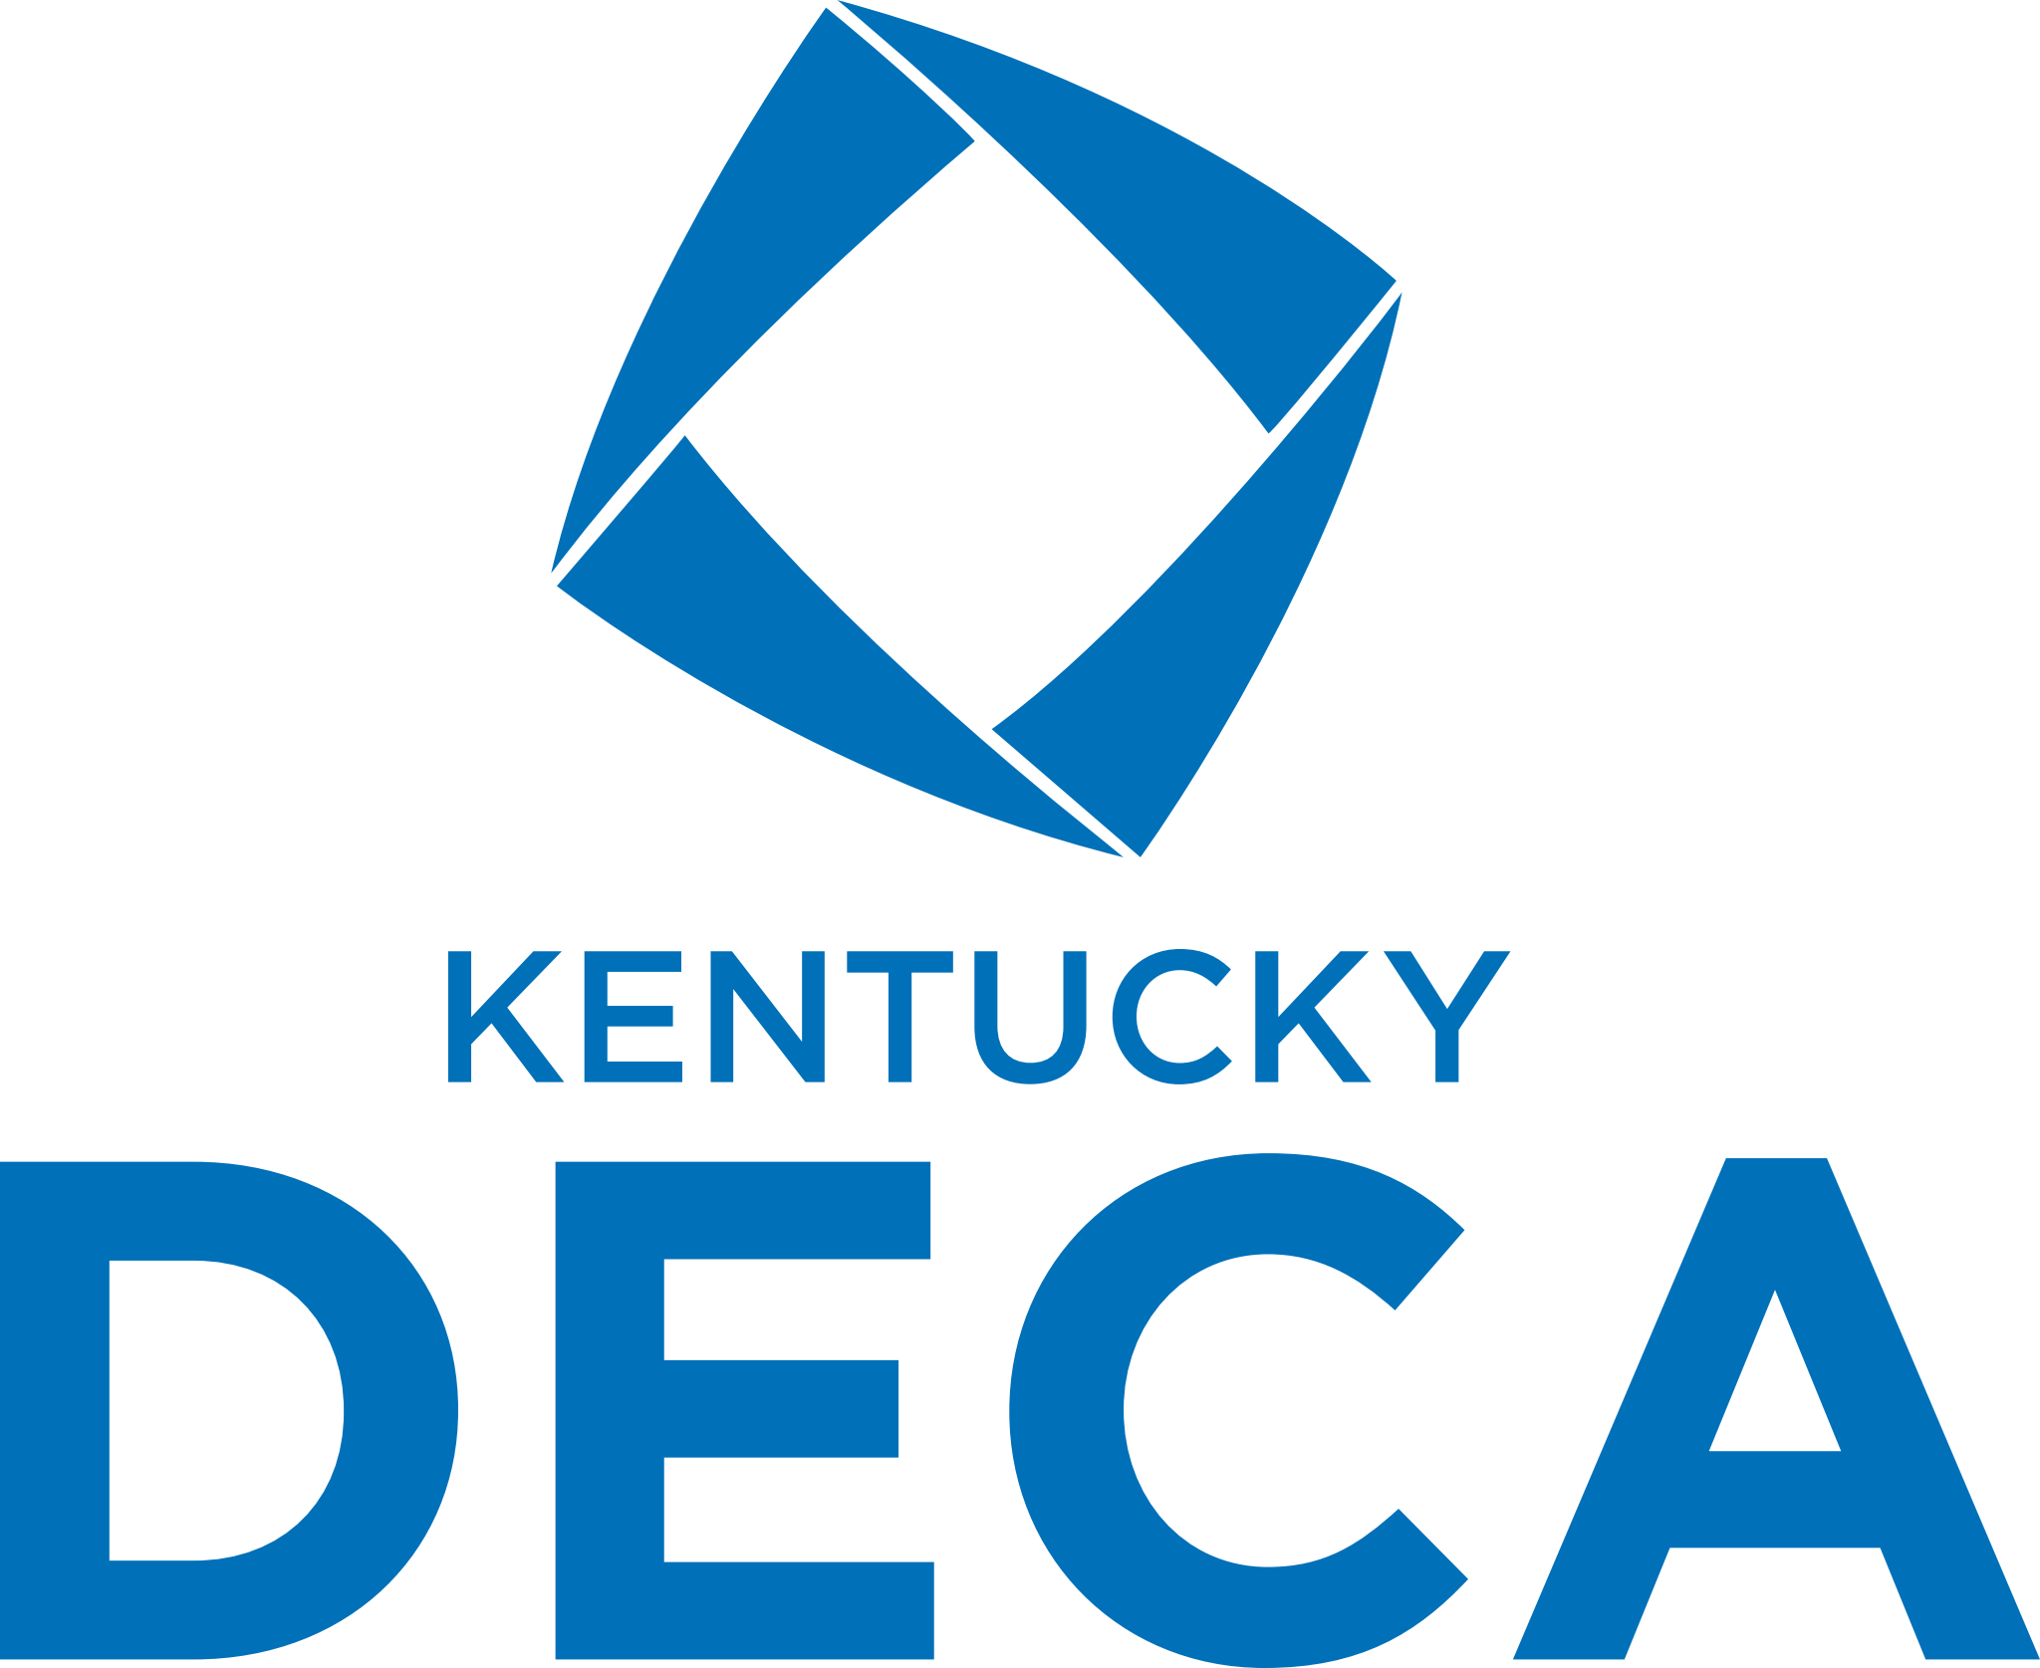
COVID WAIVER AND RELEASE OF LIABILITY
To be completed by all Event Participants

ADULT/STUDENT 18 YEARS OF AGE AND OLDER

Kentucky DECA has implemented protective measures and protocols aimed at reducing the likelihood of spread of the novel coronavirus (Covid-19) between participants and others attending its events. These measures and protocols are designed to be consistent with current guidance from the U.S. Centers for Disease Control and Prevention (CDC), as well as state and local authorities. However, Kentucky DECA cannot guarantee that event participants will not be exposed to Covid-19 while participating in or attending its events.

By signing this agreement, I acknowledge the risk of Covid-19 transmission while participating in or attending Kentucky DECA’s events and further acknowledge that I am knowingly assuming that risk by voluntarily participating in or attending an event. I further agree to comply with all protective measures and protocols implemented by Kentucky DECA, the event’s host hotel, the event’s suppliers and partners, and/or established by the CDC and state or local authorities.
I specifically affirm and attest to the following, to the best of my knowledge:

• I am not presently experiencing any symptoms of Covid-19, including, but not limited to, a fever in excess of 100.4 degrees, cough, shortness of breath or difficulty breathing, sore throat, body aches or chills, or new loss of taste or smell;
• I have not been in close contact with someone with a suspected or confirmed case of Covid-19;
• I have not been diagnosed with Covid-19 and not yet been cleared as non-contagious by my medical provider or public health authorities, consistent with CDC guidance;
• If I (i) develop any symptom of Covid-19, (ii) come in close contact with someone with a suspected or confirmed case of Covid-19, or (iii) am diagnosed with Covid-19, I will not attend the event;
• I am following all guidance from the CDC and state and local authorities regarding Covid-19 and limiting exposure to the Covid-19 virus.

Accordingly, I voluntarily agree to assume all risks and accept sole responsibility for any Covid-19 infection that may result due to my participation in or attendance at the event. I hereby release, covenant not to sue, discharge, and hold harmless Kentucky DECA, its employees, agents, and representatives, of and from any claims associated with, arising from, or related to Covid-19 infection, including all liabilities, claims, actions, damages, costs or expenses of any kind arising out of or relating thereto. I understand and agree that this release includes any claims based on the actions, omissions, or negligence of Kentucky DECA, its employees, agents, and representatives, whether a Covid-19 infection occurs before, during, or after my participation in or attendance at the event.

Signature _________________________________________________ Date:____________

Printed Name _______________________________________________________________

MINOR

Kentucky DECA has implemented protective measures and protocols aimed at reducing the likelihood of spread of the novel coronavirus (Covid-19) between participants and others attending its events. These measures and protocols are designed to be consistent with current guidance from the U.S. Centers for Disease Control and Prevention (CDC), as well as state and local authorities. However, Kentucky DECA cannot guarantee that event participants will not be exposed to Covid-19 while participating in or attending its events.

By signing this agreement, I acknowledge, on behalf of myself and my minor child(ren) named below, the risk of Covid-19 transmission while participating in or attending Kentucky DECA’s events and further acknowledge that we are knowingly assuming that risk by voluntarily participating in or attending an event. We further agree to comply with all protective measures and protocols implemented by Kentucky DECA, the event’s host hotel, the event’s suppliers and partners, and/or established by the CDC and state or local authorities. We specifically affirm and attest to the following, to the best of our knowledge:

• We are not presently experiencing any symptom of Covid-19, including, but not limited to, a fever in excess of 100.4 degrees, cough, shortness of breath or difficulty breathing, sore throat, body aches or chills, or new loss of taste or smell;
• We have not been in close contact with someone with a suspected or confirmed case of Covid-19;
• We have not been diagnosed with Covid-19 and not yet been cleared as non-contagious by our medical provider or public health authorities, consistent with CDC guidance;
• If any of us (i) develops any symptom of Covid-19, (ii) comes in close contact with someone with a suspected or confirmed case of Covid-19, or (iii) is diagnosed with Covid-19, we will not attend the event;
• We are following all guidance from the CDC and state and local authorities regarding Covid-19 and limiting exposure to the Covid-19 virus

Accordingly, I (individually and on behalf of my minor child(ren) listed below) voluntarily agree to assume all risks and accept sole responsibility for any Covid-19 infection that may result due to our participation in or attendance at the event. On my behalf, and on behalf of my minor child(ren) listed below, I hereby release, covenant not to sue, discharge, and hold harmless Kentucky DECA, its employees, agents, and representatives, of and from any claims associated with, arising from, or related to Covid-19 infection, including all liabilities, claims, actions, damages, costs or expenses of any kind arising out of or relating thereto. I understand and agree that this release includes any claims based on the actions, omissions, or negligence of Kentucky DECA, its employees, agents, and representatives, whether a Covid-19 infection occurs before, during, or after our participation in or attendance at the event.

Signature _________________________________________________ Date:____________

Printed Name _______________________________________________________________

Names of minor family members participating in or attending event:

____________________________________ _________________________________

____________________________________ _________________________________

Kentucky DECA
Photo/Video Release and Waiver - Student

I, ____________________________________________________ (Parent/Guardian Name), give consent to Kentucky DECA, or any party authorized by Kentucky DECA, to use (circle one) my son’s/my daughter’s photograph or video taken for any Kentucky DECA purpose including, but not limited to, use in publications (periodicals, books, brochures, etc.), video and audio productions, advertising and promotional materials, or other media. I release Kentucky DECA from any and all liability that may arise in connection with such use. I am the parent or legal guardian of the child named below and have the legal authority to execute this consent and release. Signature of Parent/Guardian:_________________________________________________
Relationship to Child:_______________________________________________________
Child’s Name: _____________________________________________________________
Date of Signature: _________________________________________________________

KENTUCKY DECA HONOR CODE
Integrity and honor are integral elements of ethical, responsible leadership. In a community devoted to learning, a foundation of integrity and honor among individuals must exist if that community is to thrive with respect and harmony among its members. Great care must be taken in maintaining academic integrity and honor while preparing students/members for their future careers, and as they grow into future leaders. It is the individual responsibility of every member, local adviser, and state adviser to maintain and enforce these standards. In order to administer such a high standard across our organization, every competitor must agree and certify to the compliance of the following guidelines for any competitive events into which they are registered:
1. The contents of any and all DECA competitive event entry/ies, and any answers or solutions provided, are solely the work of the undersigned competitor and/or his/her team members.
2. The DECA competitive event guidelines related to this event were read and followed, along with any supplemental guidelines for the Career Development Conference.
3. No help was sought beyond that allowed in any DECA competitive event instructions or guidelines; nor any supplemental guidelines created for the Career Development Conference.
4. No more time was taken than allowed by DECA competitive event guidelines, and all video recordings, if required, were submitted for judging were recorded in one take.
5. No textbooks, reference materials, or other aids not specifically allowed in the DECA competitive event guidelines were or will be used.
6. In the case of extemporaneous presentations, no cases, prep materials, student notes, or associated items were provided or used to aid the undersigned competitor(s) prior to recording of the presentation and that all the above listed, if utilized, were destroyed.
7. No DECA competitive event or test materials will be or have been saved to any storage device remaining in the possession of the undersigned competitor(s) or that of any other person; nor has it been saved to any cloud storage.
8. No portion of this entry has previously been entered into DECA competition.
9. Participation of the undersigned competitor in this, and any, DECA competitive events will take place in an honest fashion.
In the event of an alleged violation to one or more of these guidelines, the state advisor will have the authority to make an official decision in order to settle the allegation. If a violation is determined to have occurred, the entry will be subject to penalties of point deductions or disqualification at the determination of the state advisor, and information will be forwarded to the appropriate chapter adviser for potential action of academic integrity violations.
By completing the information below, I am indicating my understanding of the consequences of violating this Honor Code. I further certify that if I am under the age of 18, my parent/guardian has also read and agreed to this Honor Code.
Electronic signature will be accepted. ____________________________________________

Competitor Name: Kentucky DECA Region:
Competitor Email Address:
Competitor Age:
Date:

