October has been an exciting month for Kentucky DECA. We had a very successful Walk for a Cure for Muscular Sclerosis! We are proud to say we raised over $700. A very special thank you to our sponsors: Rusty McAlister, Financial Advisor from Edward Jones, Adams Buick and GMC, Blankenship Asphalt Tech and Training, and A1 Storage. Thank you to Eastern Kentucky University for hosting us and for the participation of our members. It’s always refreshing to see members coming together to support each other and a great cause!

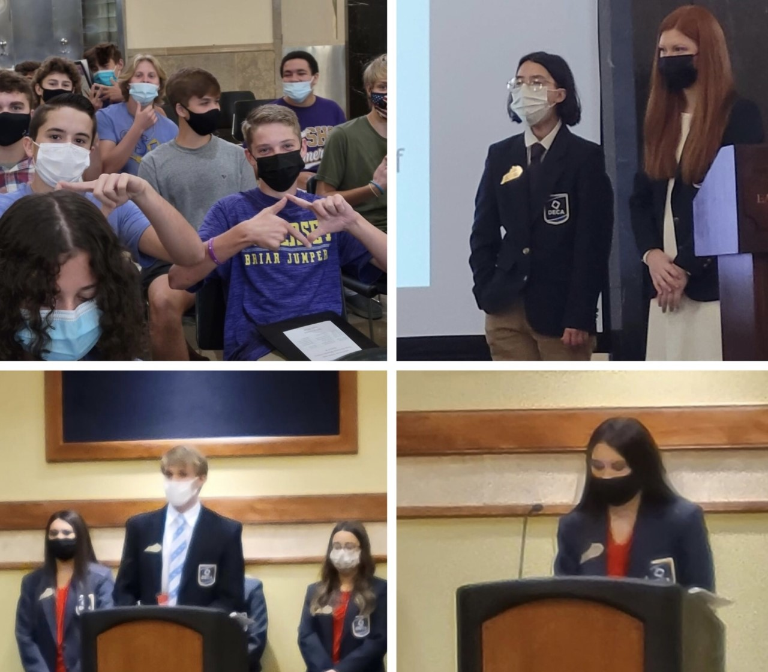
Our regional workshops have concluded. Our regional officers did a great job leading and conducting them. We greatly appreciate their hard work. DECA members across the commonwealth have participated in regional workshops to prepare for the Kentucky State Career Development Conference coming up this Spring. At the regional workshops, members learned about how to compete successfully. Whether it be a written event or a role-play, our members are informed and inspired to succeed. Not only were the regional workshops purposeful, helping members to better themselves, but they were also a great time! Members had the chance to earn gifts cards, and even DECA apparel.
As your DECA competition approaches, we encourage you to prepare before the competition. If advancing in your contest is a goal you have, many points can be added to your score from your DECA tests. Practice tests can be taken to improve your scores. Practice role-play events can also be gone over to help you advance as well. Speaking clearly, slowly, and having plenty to say can help you go far in role-play events! Dress for success, always wear a smile, and if you work hard, you might just get to wear a medal too! The Kentucky DECA Association team can’t wait to welcome you to the State Conference! We wish all competitors the best of luck at their upcoming regional contests!

